**Class Diagram for InClass Exercise**

This is the Class Diagram for the Home Security System. Here Controller is the main class that controls all the other classes. Entry Sensor, Smoke Sensor, Temperature Sensor and Flood Sensors are represented as classes along with their attributes and operations.



**Sequence Diagram for InClass Exercise**

This is the sequence diagram for Home Security System showing how the program is responding to alarm.

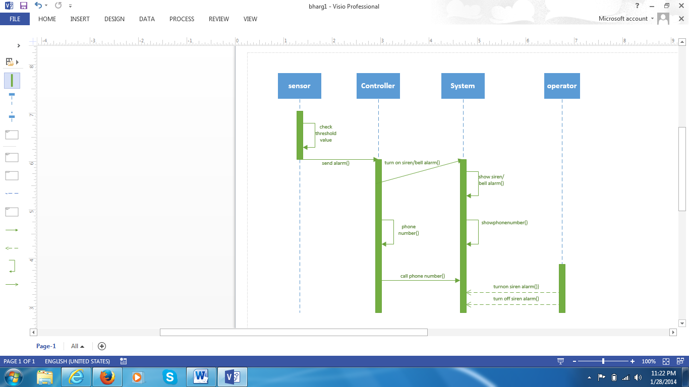

This is the Sequence diagram for Home Security System showing how the operator turns the system off.

